In Teachers Page
Add teacher
- Make subjects select to choose subject and make it required and make phone required
- When add attachments in add modal it added but not uploaded when edit or show modal , attachments not appear
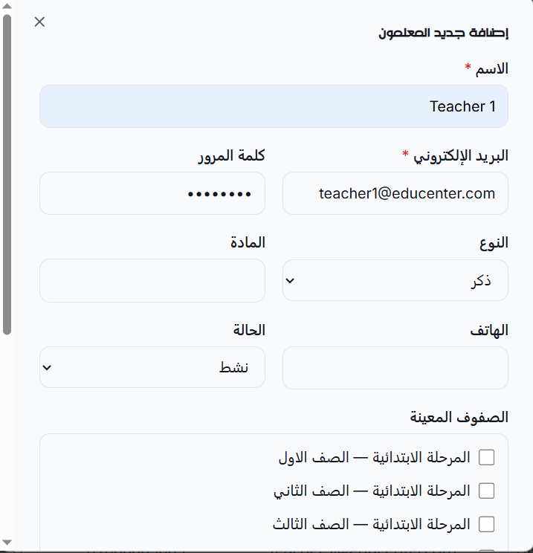

Grades Page
Delete
- When delete grade it disappear from table and when reload or return to page , it appear again

Classes Page
Add
- Notes not added when add class
Edit
- Notes not updated when edit class

Sections Page
- Data must appear from new to old

Delete
- When delete section it disappear from page and when reload or return to page , it appear again

Units Page
- Data must appear from new to old
- Disappear delete button from page , if there are more that lesson in unit .

Homework Page
- Data must appear from new to old

Library Page
- When click on download button it redirect to page of file with 404 not found

Session Page
- UI/UX of this page need to enhance
- Remove “Delete” button , if session has related records (attendance , quiz , exam)
Add
- Make section select searchable , make them grouped by grade and class
- Make default minutes (60)
- Take location from center settings
- Don’t add two session for same section in same day

Attendance Page
- UI/UX of this page need to enhance
- Remove “today attendance” button , will be related to session

Quiz Page
- UI/UX of this page need to enhance
- Remove “today quiz” button , will be related to session

Exam Page
- UI/UX of this page need to enhance
- Remove “today exam” button , will be related to session

Fees Page
- UI/UX of this page need to enhance
- Data must appear from new to old
- Add button that redirect to related payments of fee
- Remove delete button for fees that has payments

Announcements Page
Add
- Type select option not translated
- When click on save , error appear
Notifications Page
- Enhance ui ux of page

Whatsapp Page
- Enhance ui ux of page

Whatsapp Templates Page
- Handle variable to add variable name in message when click on variable name not add it manual

Certifications Page
- In content show variable names as buttons when click on it add to content in current location

Create Landing Page
- Add Arabic teachers landing templates

